LAB 4:

Question 1:
Write a function to sort an array using Insertion Sort and then search for a given element using Binary Search.
- Your program should take an unsorted list of integers and a target value as input.
- First, sort the list using Insertion Sort.
- Then, implement Binary Search on the sorted list to find the target.
- Return the index of the target if found, or -1 if not found.
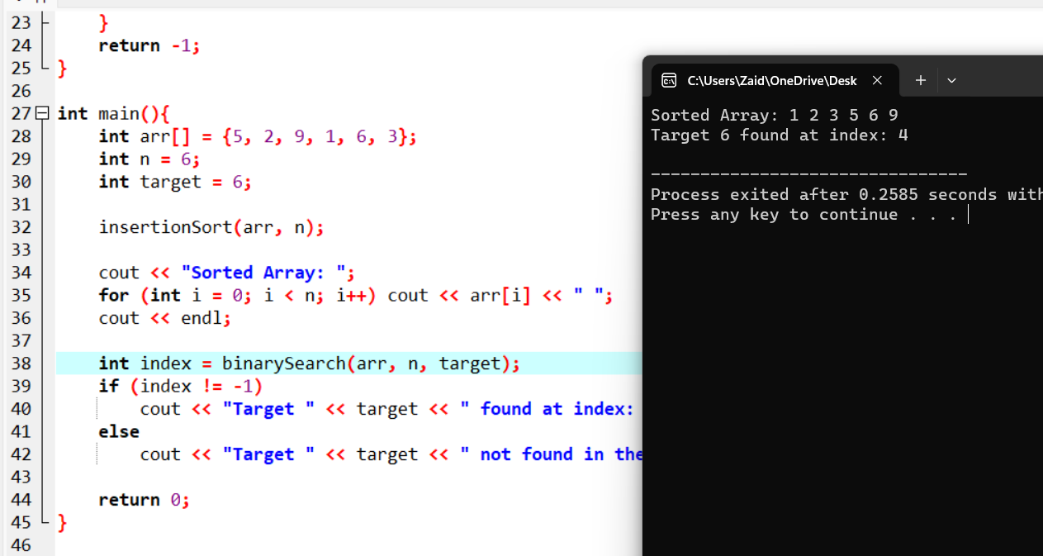

Question 2:
Write a program that:
- Takes an unsorted array and a target element as input.
- Sorts the array using Selection Sort.
- Implements Interpolation Search to find the target in the sorted array.
- Return the index of the target element if found, otherwise return -1.
- Handle the case where the array contains duplicates or the target is out of range gracefully.
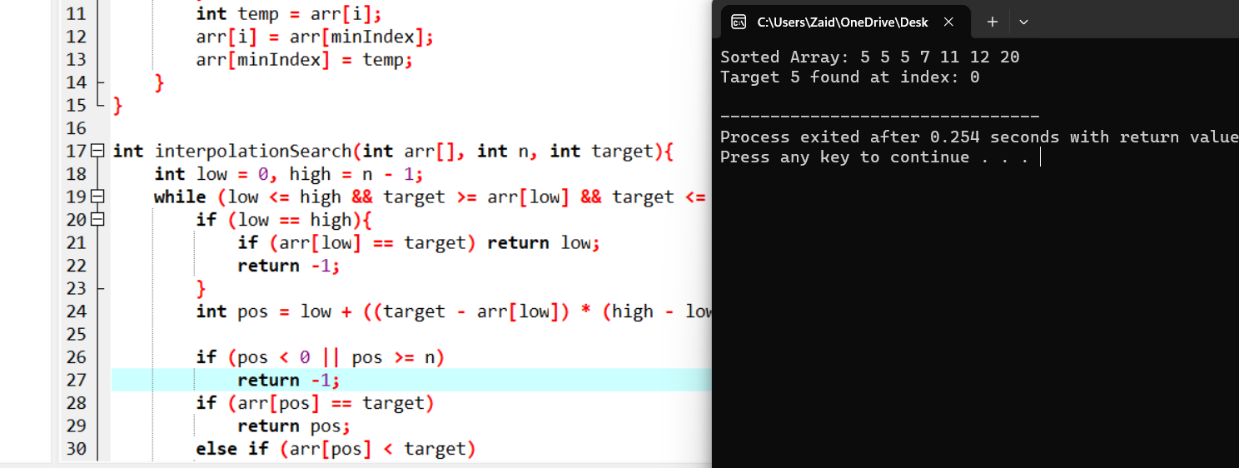

Question 3:
Write a function to:
- Perform Bubble Sort on a given array to sort it in ascending order.
- Implement Linear Search to find the first occurrence of a target element in the sorted array.
- Return the index of the target if found, or -1 if not.
- Your function should print the sorted array and the search result.
